**Testing runs**

When started program.

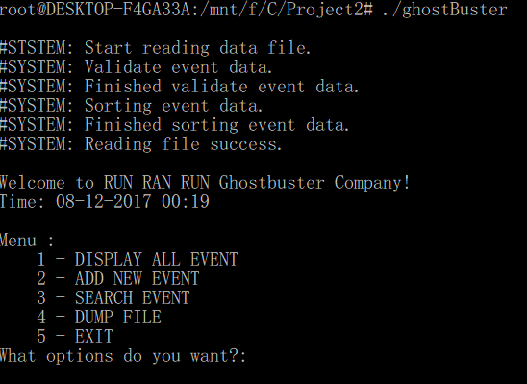

When select display all of event.

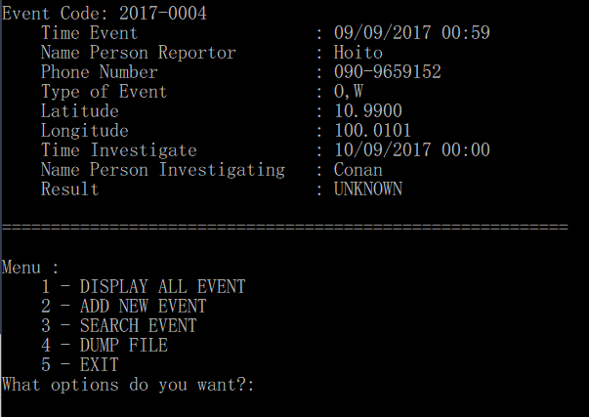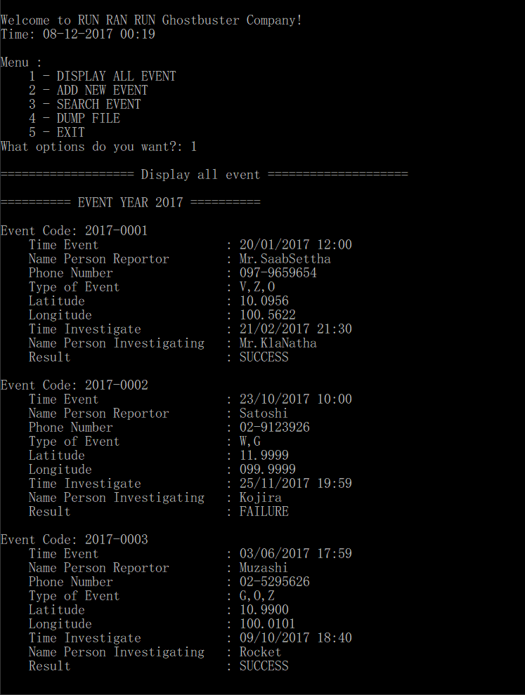

When select add new event.

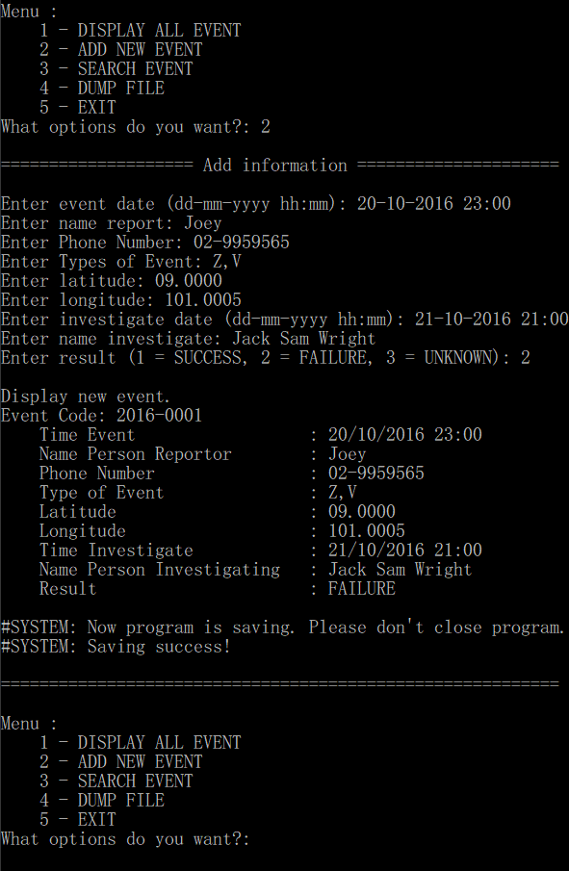

When select search event by event code and edit the data.

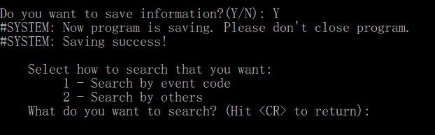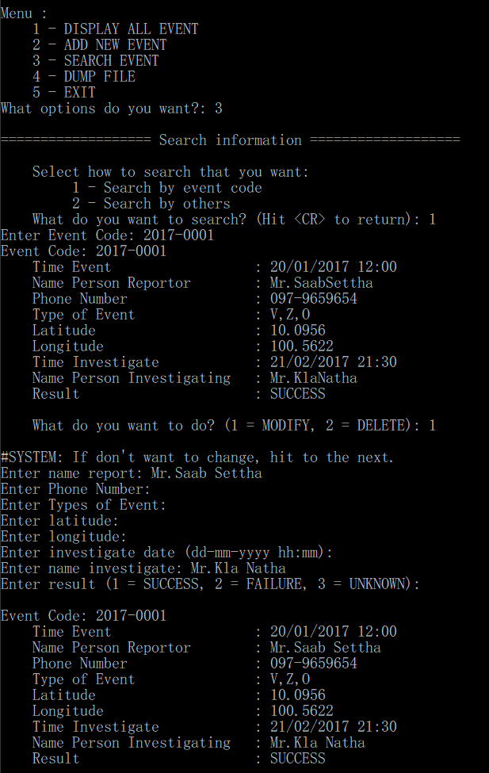

When select search event by others and select event code to delete the data.

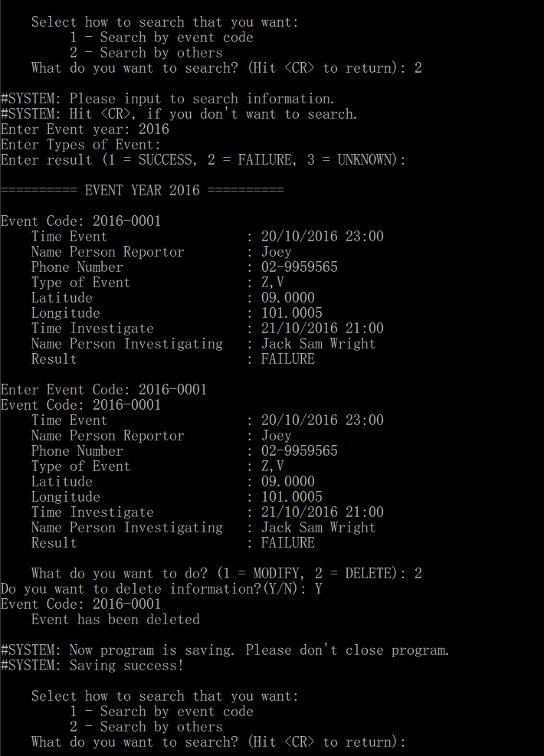

When select search event with others and select event code to delete the data.

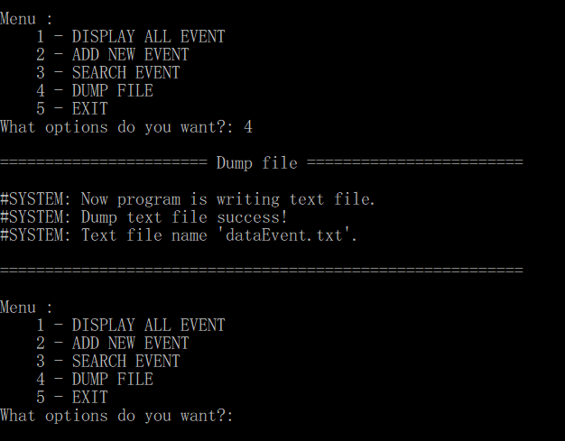

**Dumped Text file (dataEvent.txt)**

Event Code: 2016-0001

Event has been deleted

Event Code: 2017-0001

Date and Time Event: 20/01/2017 12:00

Name Person Reportor: Mr.Saab Settha

Phone Number: 097-9659654

Type of Event: V,Z,O

Latitude: 10.0956

Longitude: 100.5622

Date and Time Investigate: 21/02/2017 21:30

Name Person Investigating: Mr.Kla Natha

Result: SUCCESS

Event Code: 2017-0002

Date and Time Event: 23/10/2017 10:00

Name Person Reportor: Satoshi

Phone Number: 02-9123926

Type of Event: W,G

Latitude: 11.9999

Longitude: 99.9999

Date and Time Investigate: 25/11/2017 19:59

Name Person Investigating: Kojira

Result: FAILURE

Event Code: 2017-0003

Date and Time Event: 03/06/2017 17:59

Name Person Reportor: Muzashi

Phone Number: 02-5295626

Type of Event: G,O,Z

Latitude: 10.9900

Longitude: 100.0101

Date and Time Investigate: 09/10/2017 18:40

Name Person Investigating: Rocket

Result: SUCCESS

Event Code: 2017-0004

Date and Time Event: 09/09/2017 00:59

Name Person Reportor: Hoito

Phone Number: 090-9659152

Type of Event: O,W

Latitude: 10.9900

Longitude: 100.0101

Date and Time Investigate: 10/09/2017 00:00

Name Person Investigating: Conan

Result: UNKNOWN

When select exit program.

